Setup & Firmware Uploading Guide
Smart Speaker

Assembly Guide

- Connect the Speaker connecting cable to the speaker
Carefully solder the Black wire to the Speaker terminal marked (-Ve). And Red wire to the speaker terminal marked (+Ve). As shown in figure: 3
After soldering the wires, connect the speaker connector (as shown in Figure 2) to the speaker connector J9 on the PCB (as shown in Figure 1).

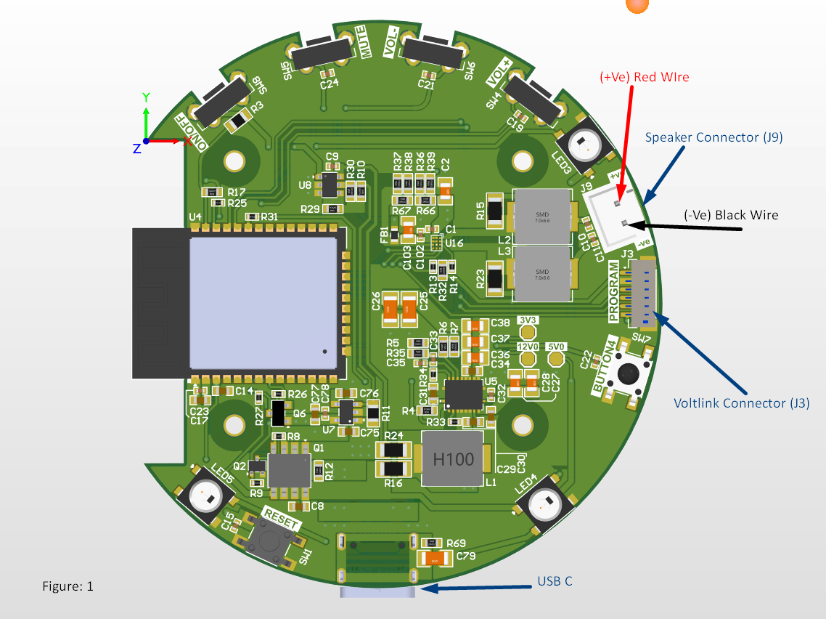
(+Ve) Red wire
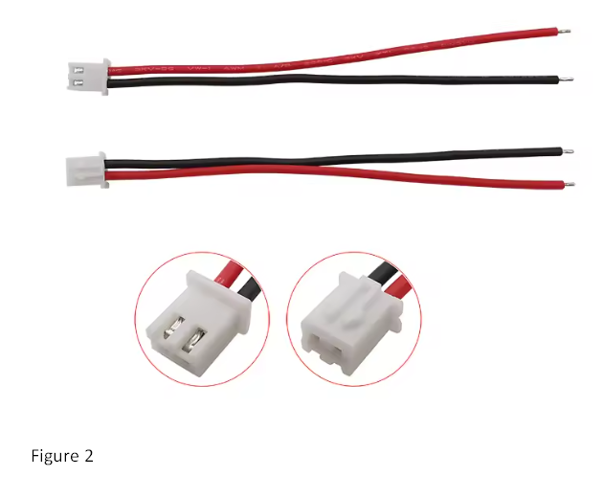 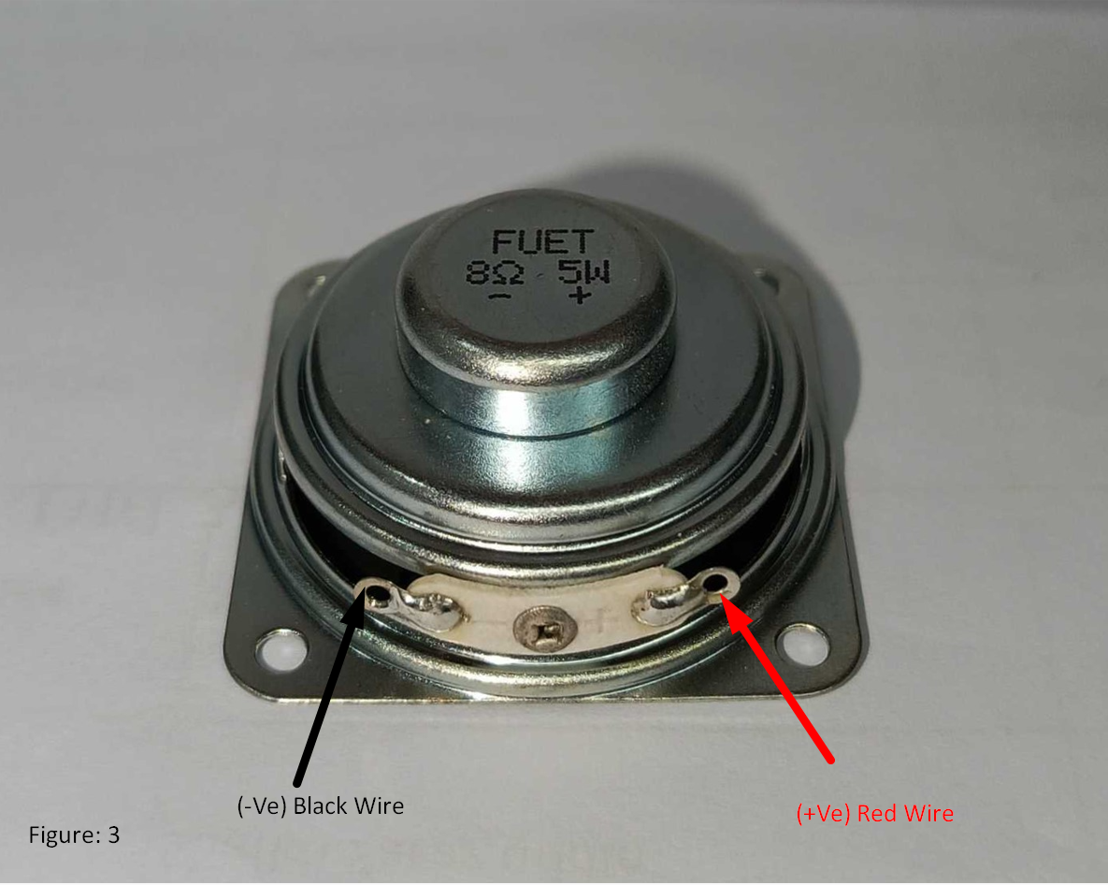

- Prepare the Board for programming by connecting it to Voltlink programmer as shown in Figure 4
Use the connection cable provided with the Voltlink adapter to connect with the Voltlink connector marked J3 in the Board
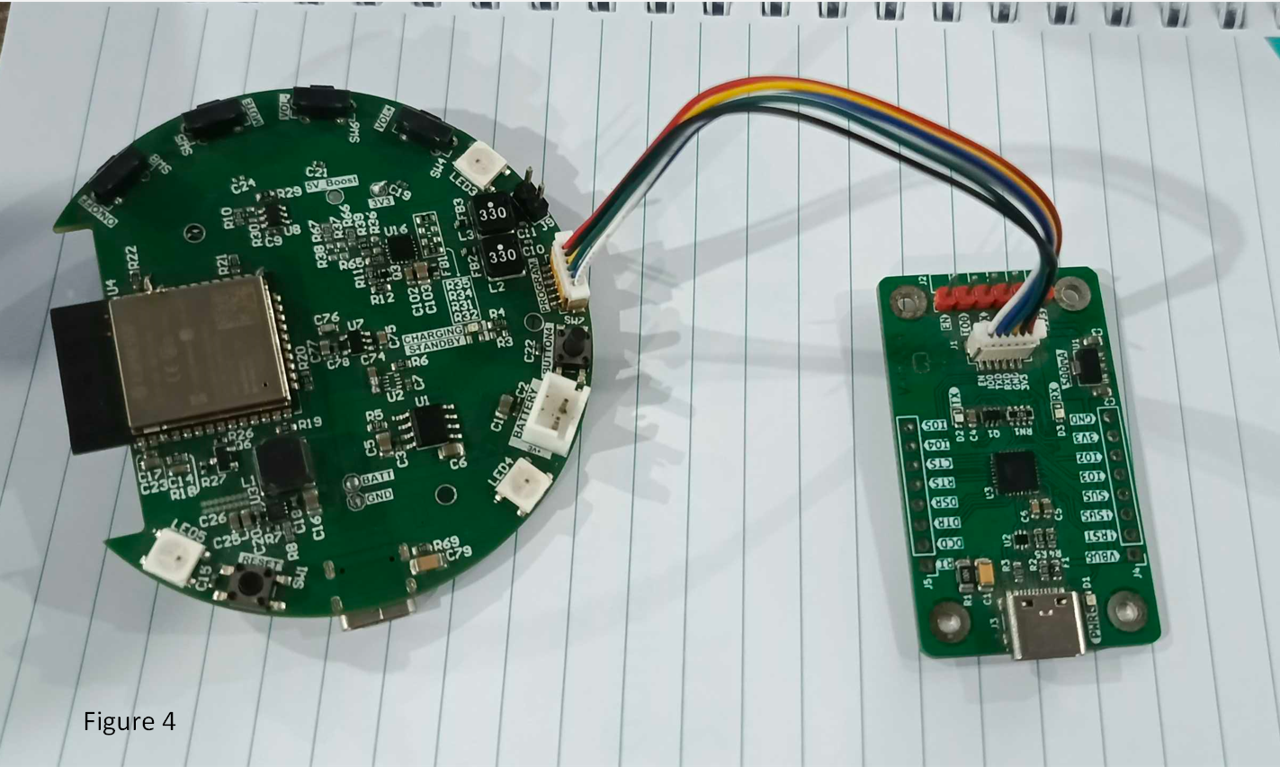

Power up Sequence
Insert the Type-C cable into the Voltlink programmer and Smart speaker board as shown in image below
